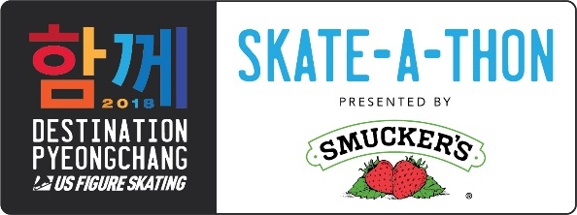
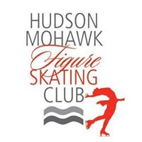

SKATE-A-THON PARTICIPANT INSTRUCTIONS
For all interested in participating in Destination PyeongChang Skate-A-Thon Ahead of 2018 Olympic Winter Games

Ice skaters of all ages are welcome to participate in this great opportunity to raise money for the USA Figure Skating Team and a local skating club, the Hudson Mohawk Figure Skating Club (HMFSC). Skaters under the age of 6 require an adult skater on the ice.

All skaters are requested to obtain sponsorships using the attached pledge sheet. Sponsors may pledge a per lap amount or a flat donation. A minimum donation of $0.20/lap or a flat donation of $20 is requested from each participating family. A HMFSC club officer will collect the cash/check donations (checks should be made payable to U.S. Figure Skating). Remember, half of all proceeds go directly to the U.S. Figure Skating team! Please bring all pledges to the event:

DATE: Sunday, January 14, 2018
TIME: 2:00 p.m. to 3:30 p.m.
LOCATION: RPI Houston Field House
1800 Peoples Avenue
Troy, NY 12180

All interested participants should bring skates and be ready for fun! A concession stand with hot cocoa and coffee and snacks will be available. Music and prizes will be awarded throughout the Skate-A-Thon!
One Grand Prize winner will be selected to win a year’s supply of Smucker’s Uncrustables and a secondary winner will receive four all-session tickets to the 2019 U.S. Figure Skating Championships. Winners may not be employees of U.S. Figure Skating or J.M. Smucker’ Company. Winners will be selected at random and will be notified by March 31, 2018.
In the competitive spirit of the Olympic Games, U.S. Figure Skating has created a Club Challenge! Clubs across the country will have the chance to win a visit from a 2018 Olympian or two all-event tickets to the 2019 U.S. Figure Skating Championships. We need your help to represent the Capital District!

SEE YOU ON THE ICE!!

For more information, please contact HMFSC at skateHMFSC@gmail.com, Tommie Palladino at jpalladino2@nycap.rr.com, or Brent Diederich, U.S. Figure Skating Manager, Giving Programs, at 719.635.5200. For more information on Destination PyeongChang, click the Destination PyeongChang logo at usfigureskating.org.

Sanctioned by US Figure Skating, 501 3 ( c ) Not for Profit

